# Common:

**1- Login (Student, Teacher, Admin)**

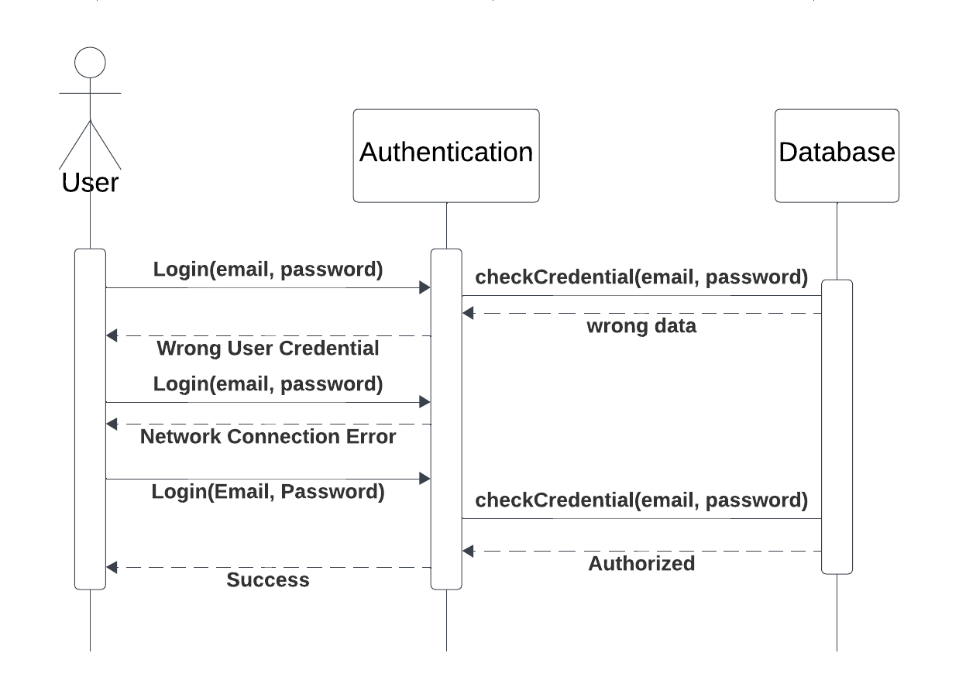

**2- Upload Material (Student, Teacher)**

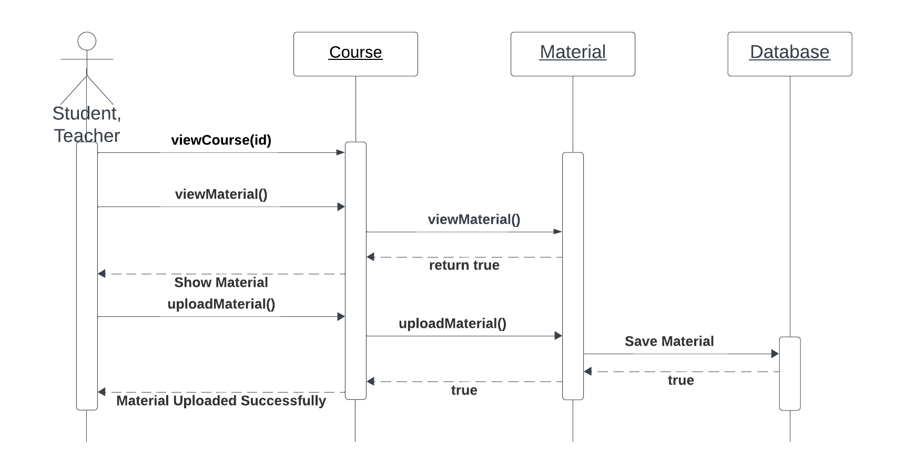

**3- Download Material (Student, Teacher)**

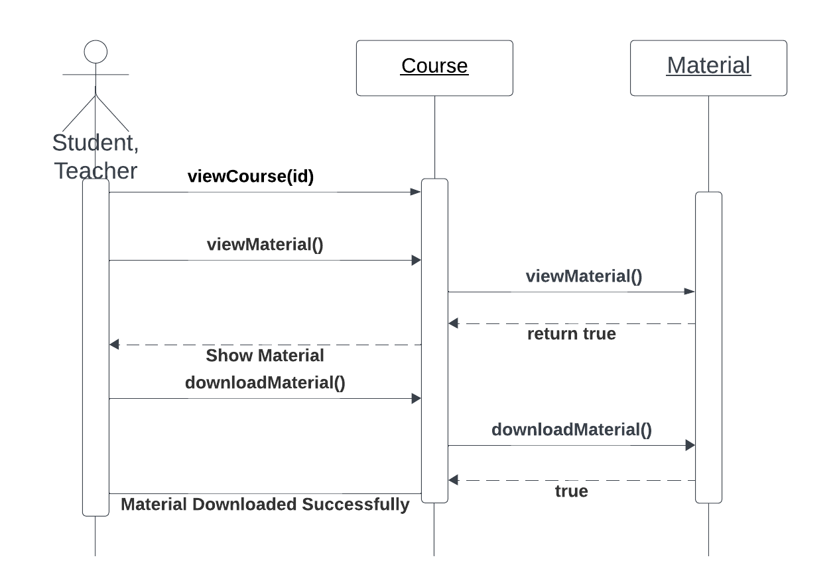

**4- Open a Ticket (Student, Teacher)**

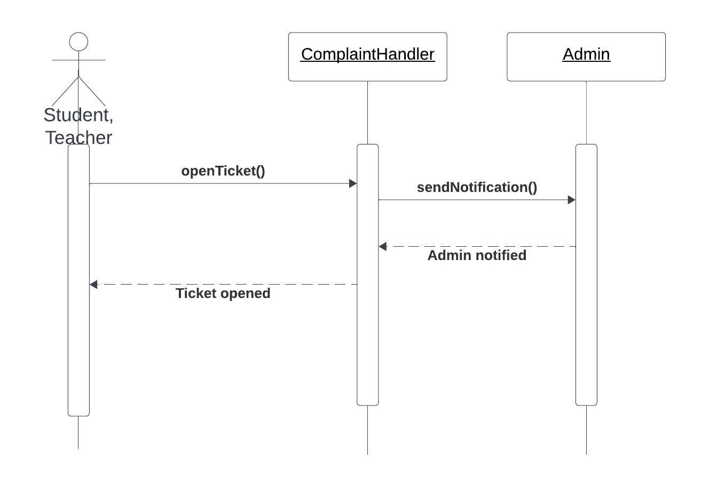

# Student:

**1- student enrolls course (normal scenario)**

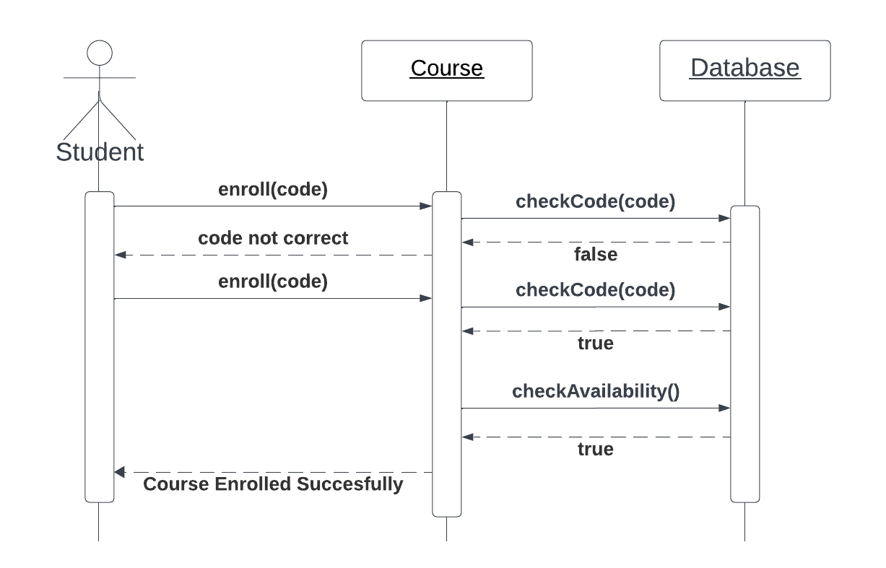

**2- student enroll course (exception scenario)   
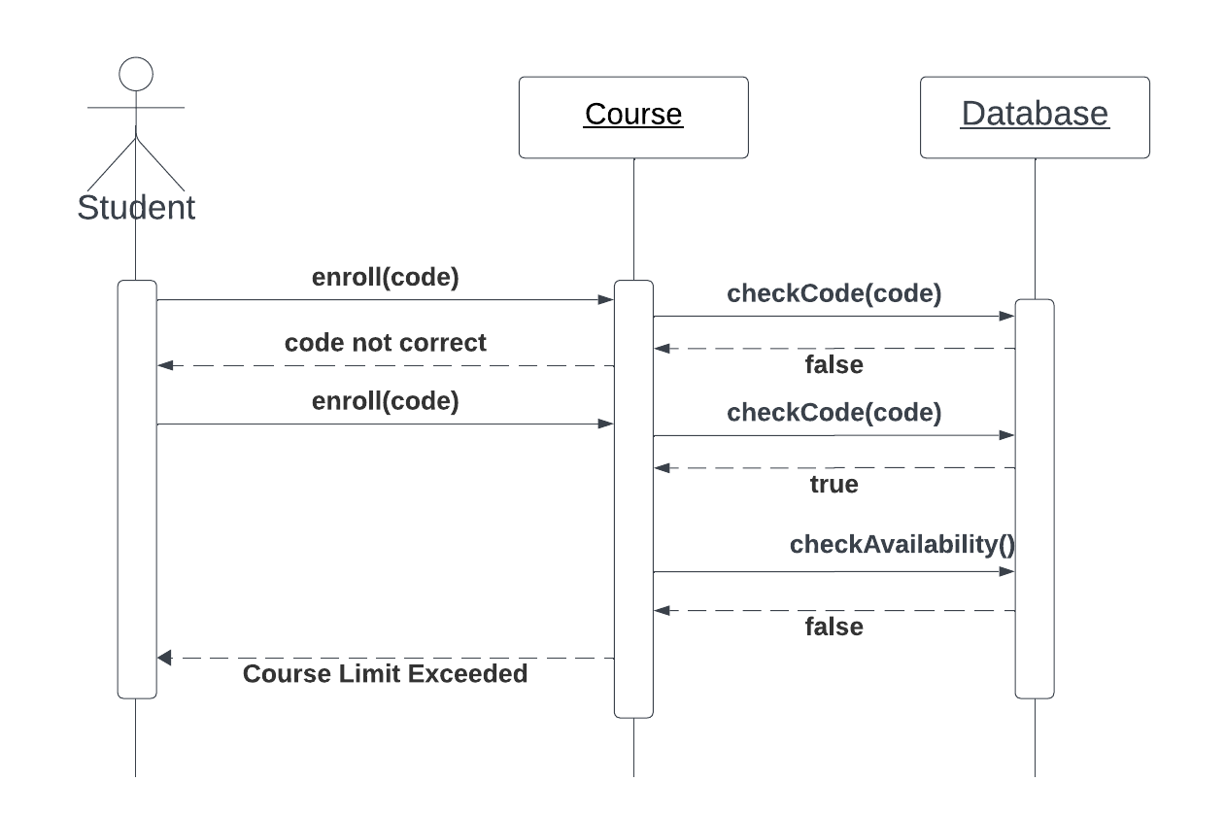**

**3- Submit assignment**

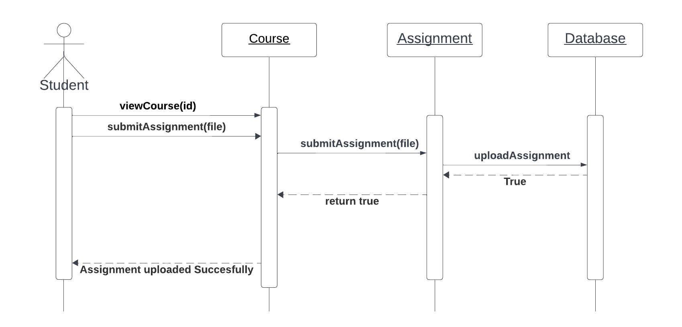

**4- take a Quiz**

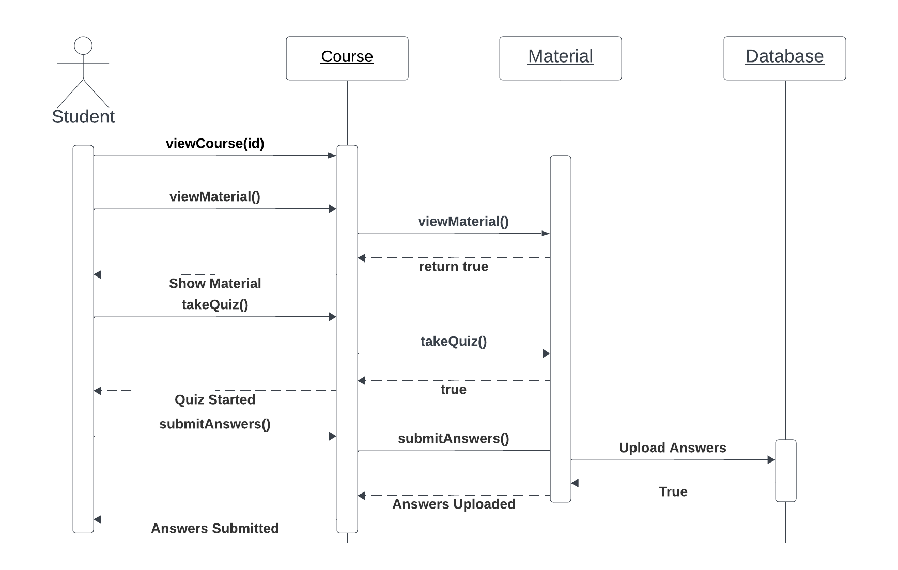

**5- Categorize Courses**

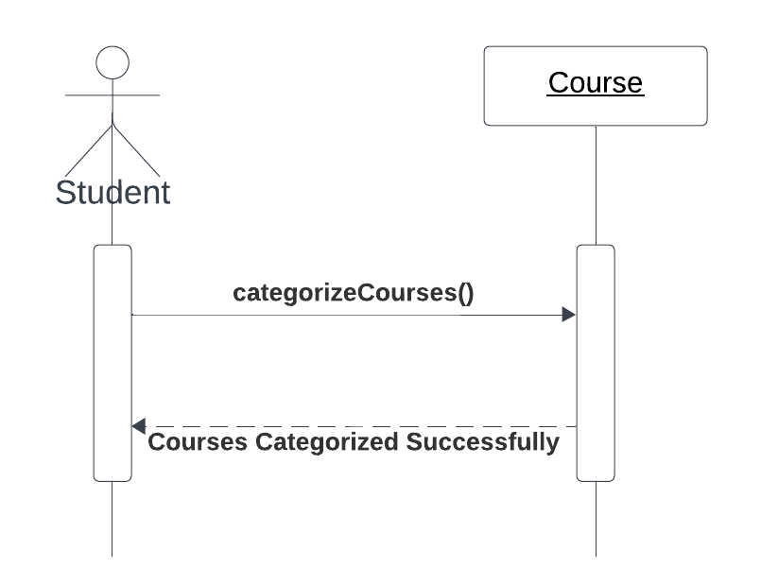

**6- Categorize Materials**

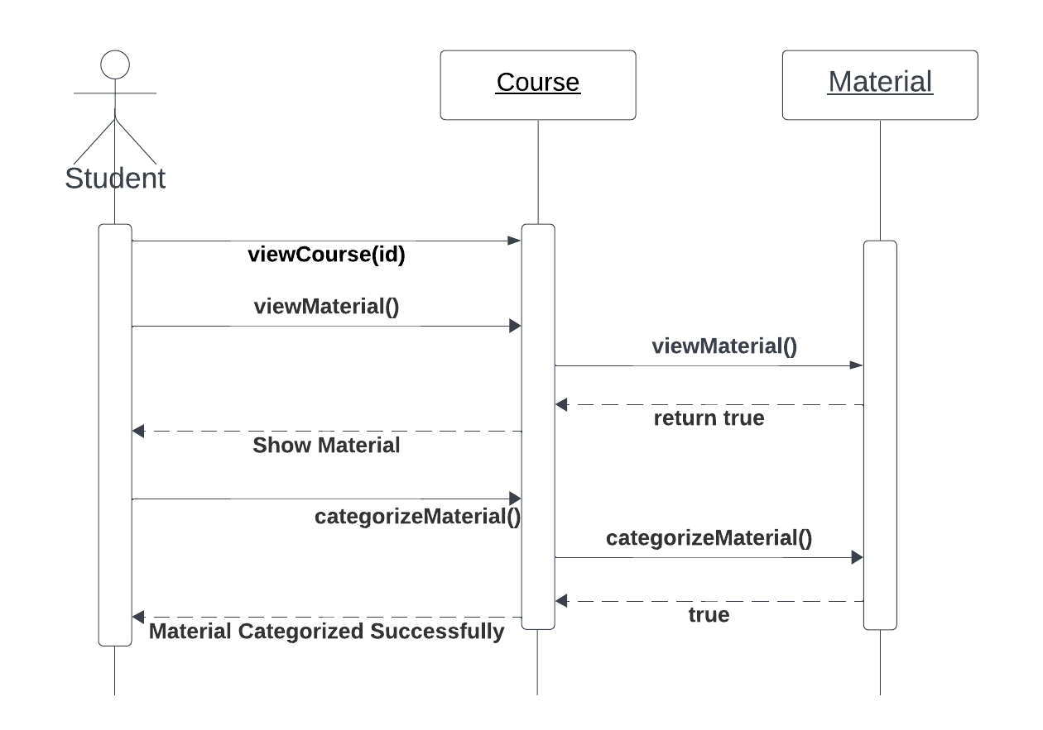

**7- Check Course Progress**

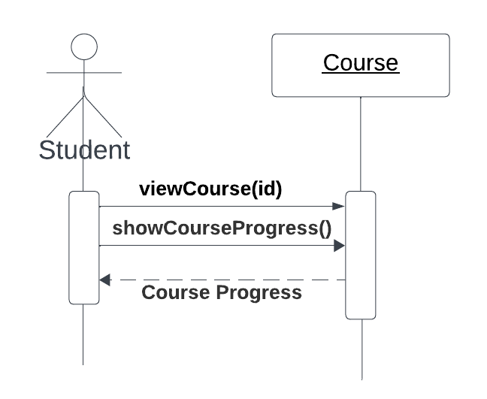

**8- Change Settings**

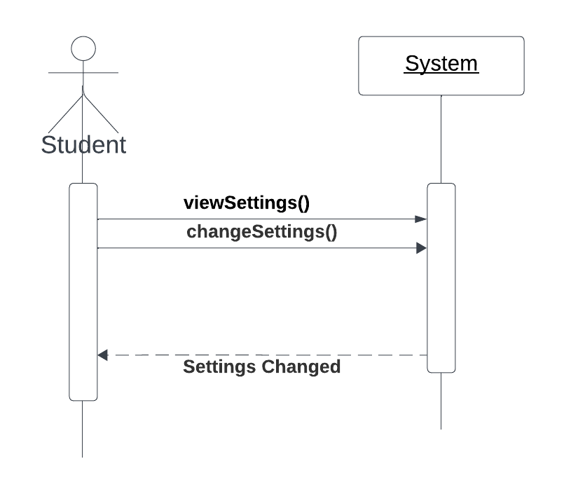

# Teacher:

**1- Update Material**

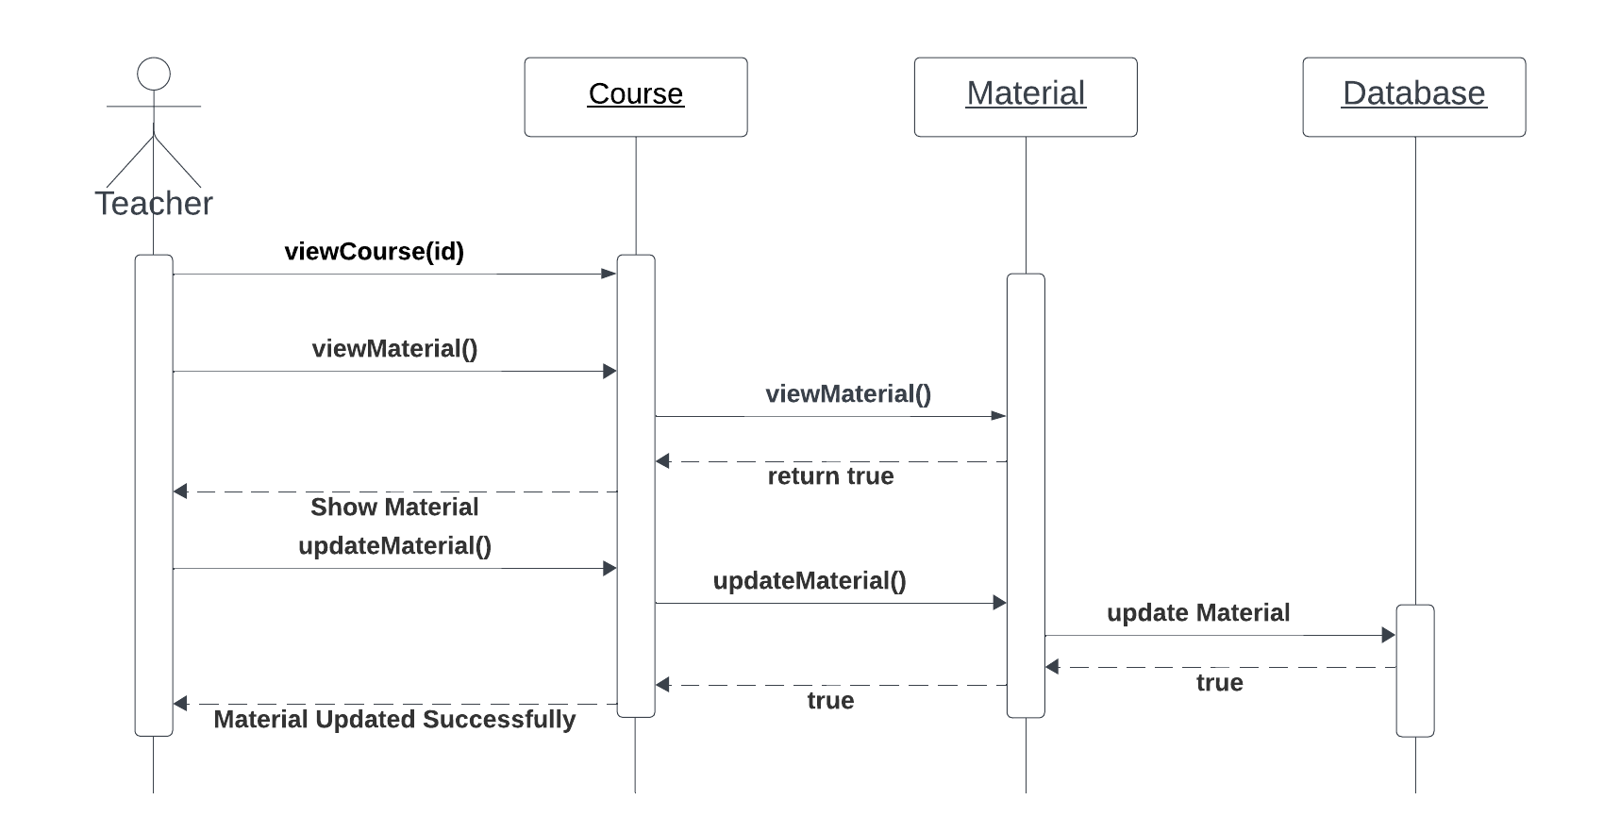

**2- Delete Material**

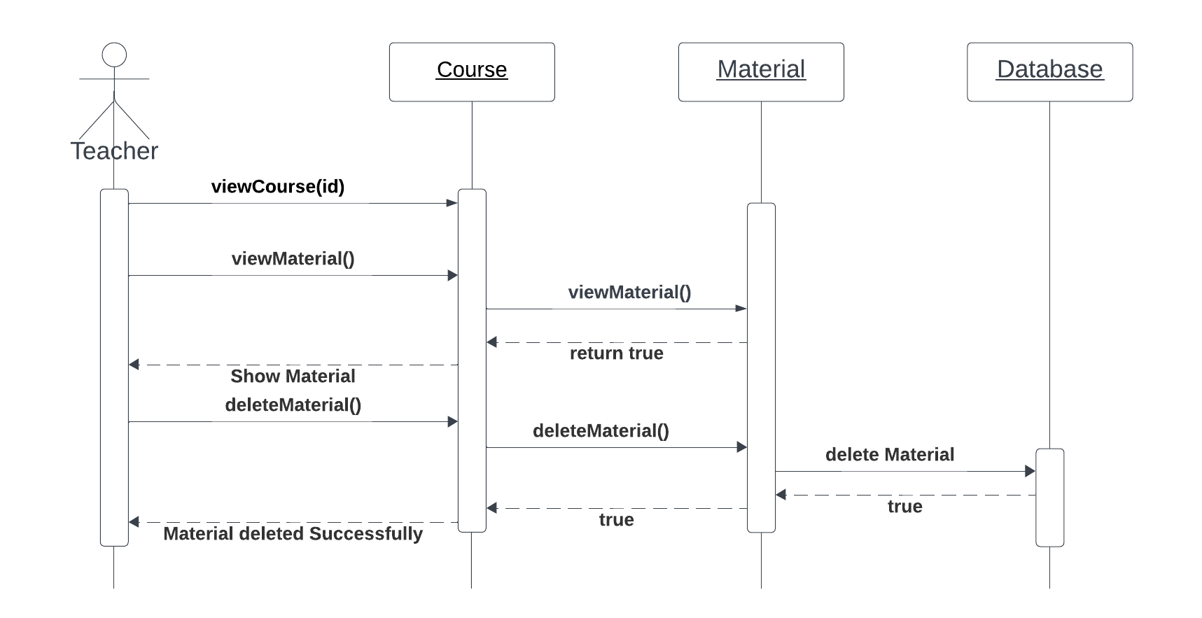

**3- Upload Assignment** 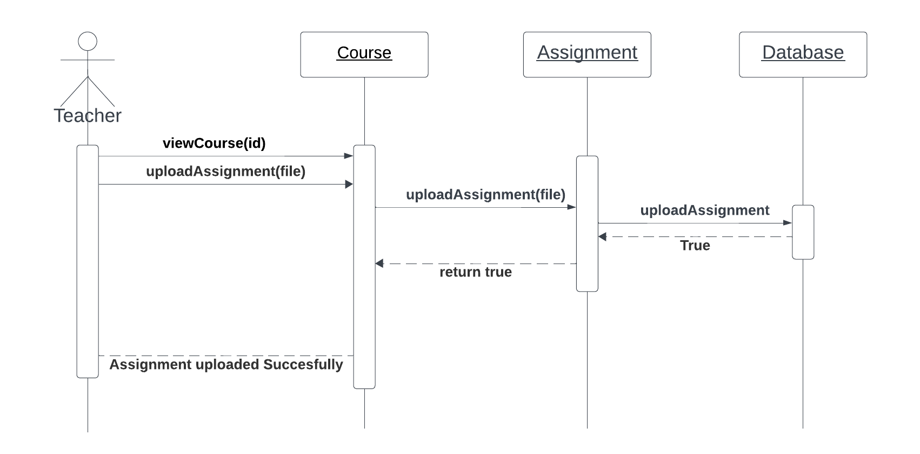

**4- Add Quiz**

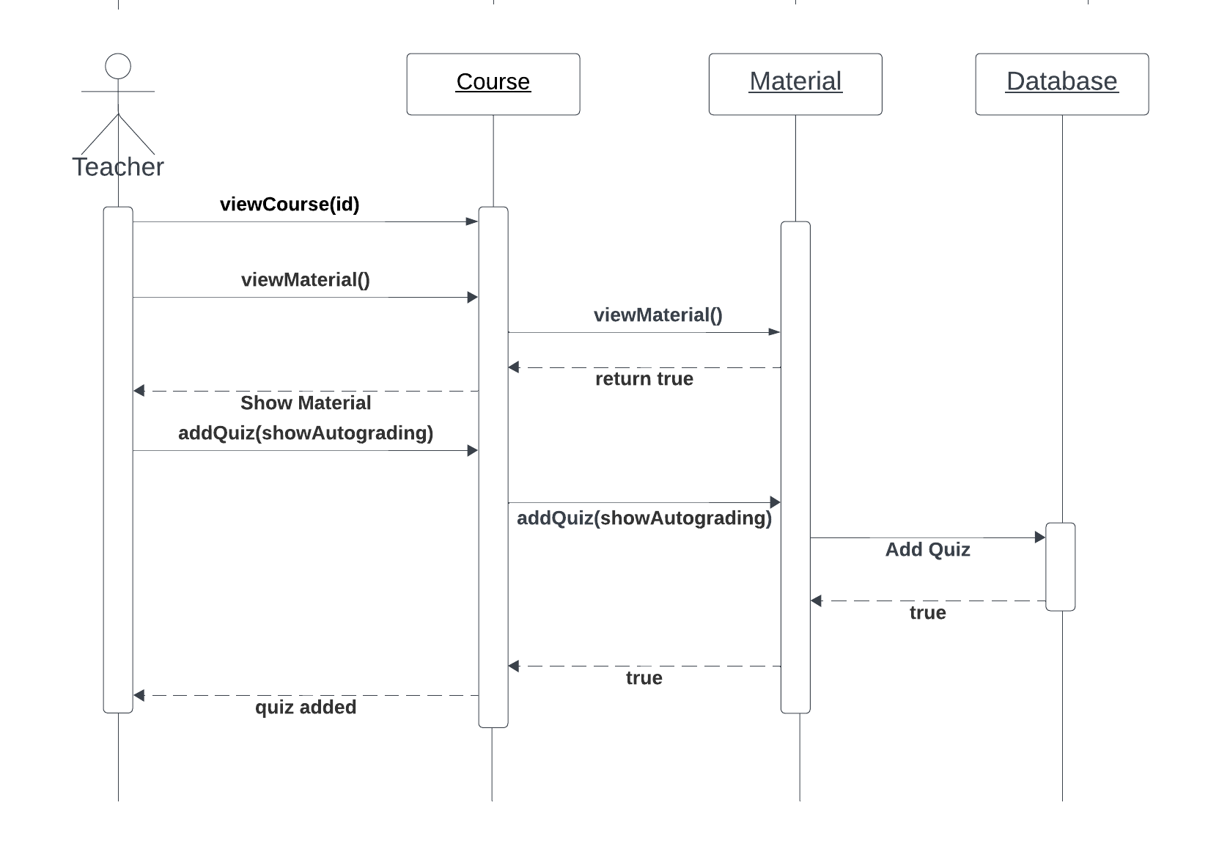

**5- Assign Rules**

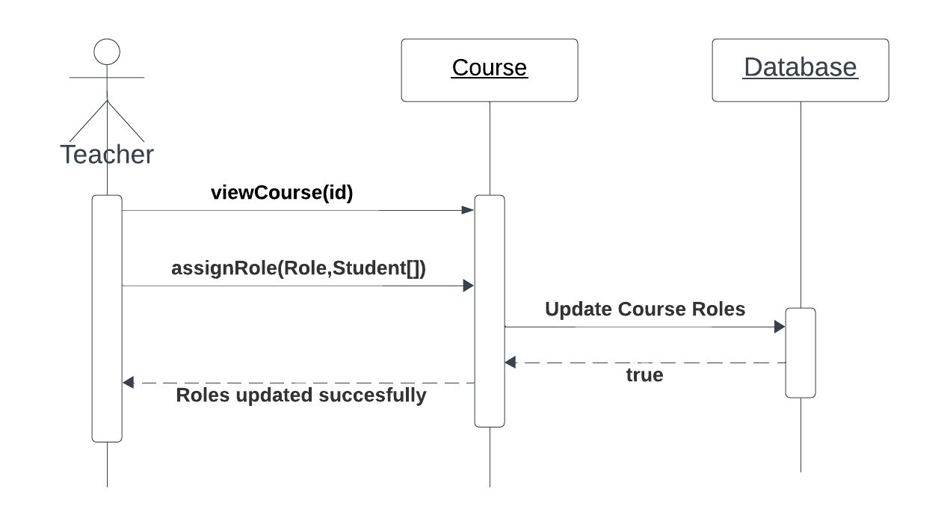

# Admin:

**1- Add Course**

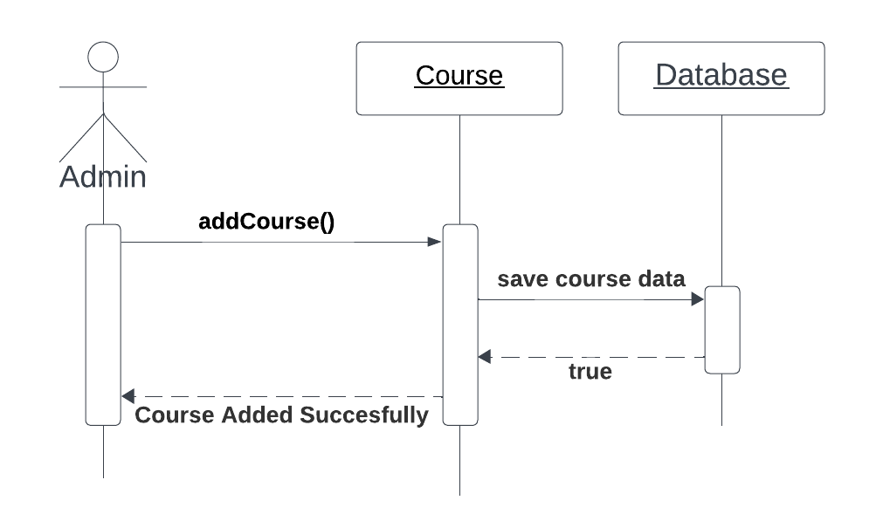

**2- Update Course**

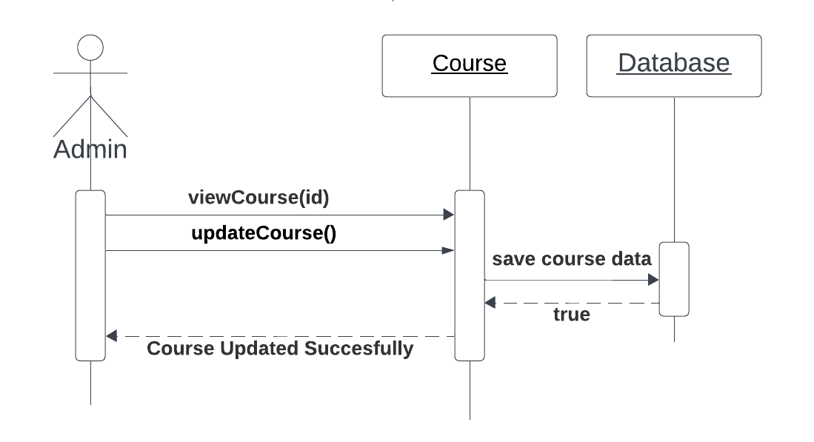

**3- Delete Course**

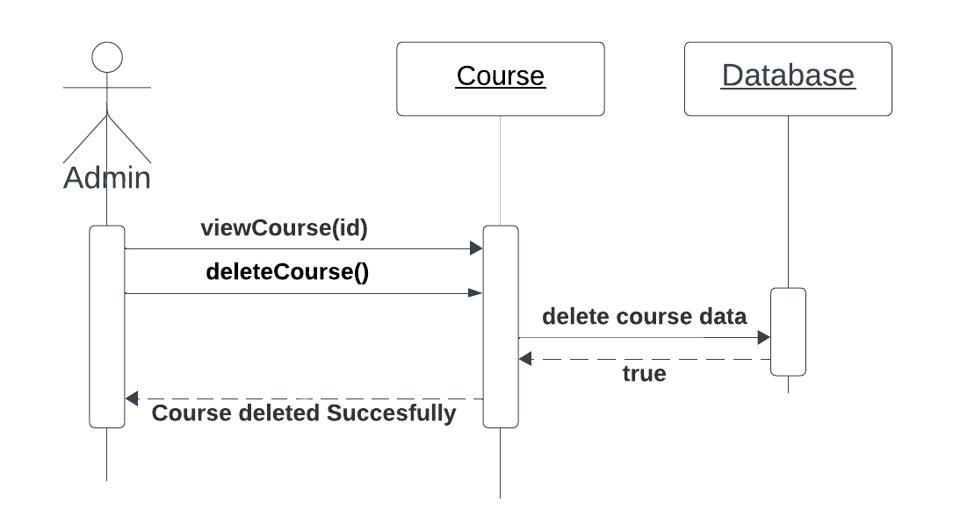

**4- Add/Register User**

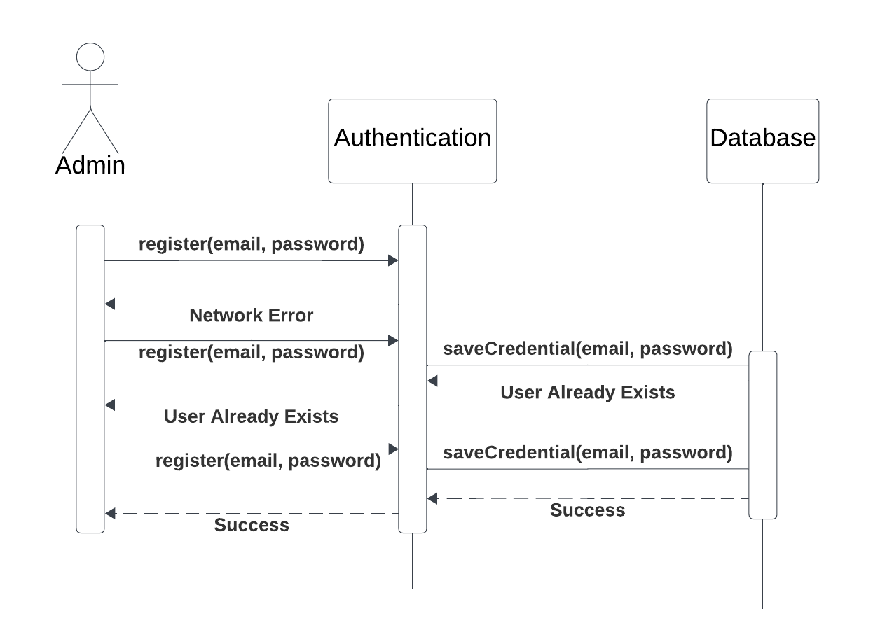

**5- Update User**

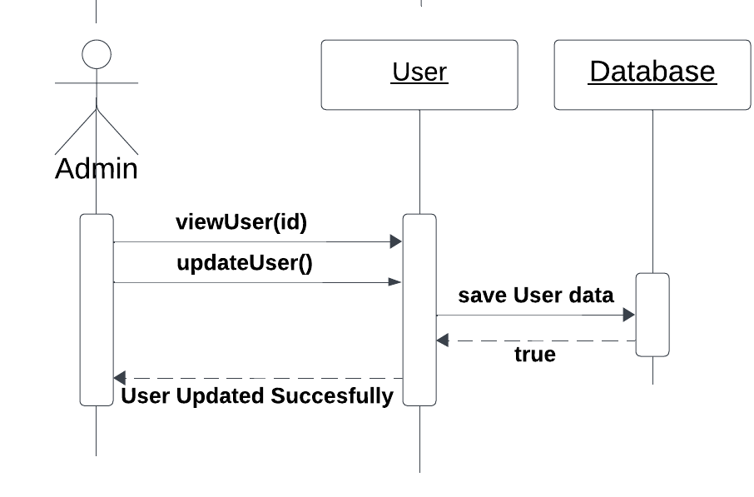

**6- Delete User**

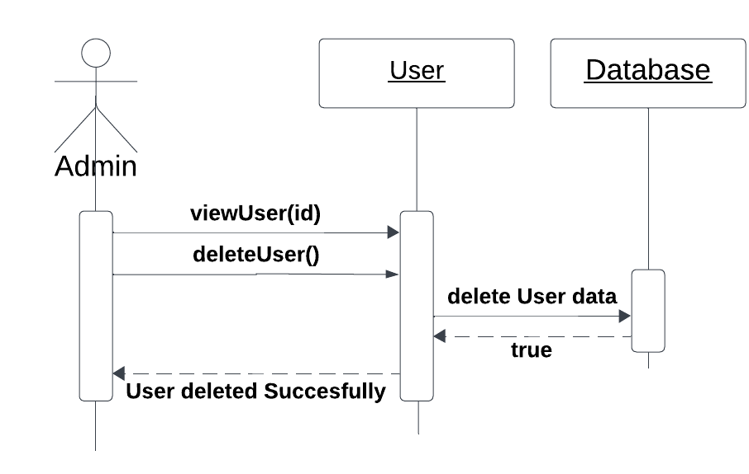

**7- Collect Reports**

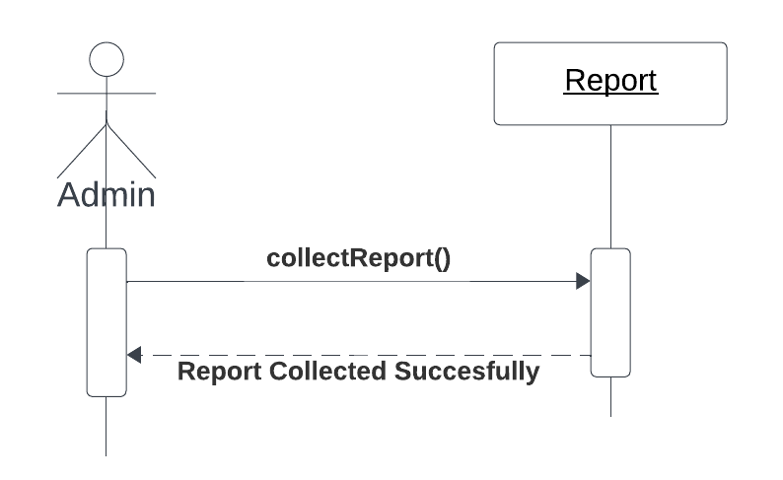

**8- Review Ticket**

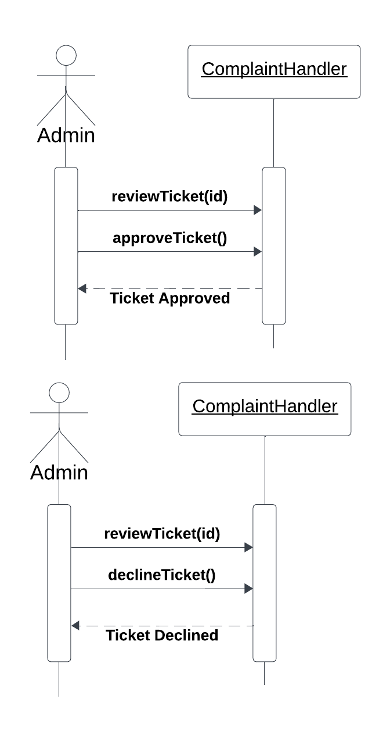

**9- Update Platform**

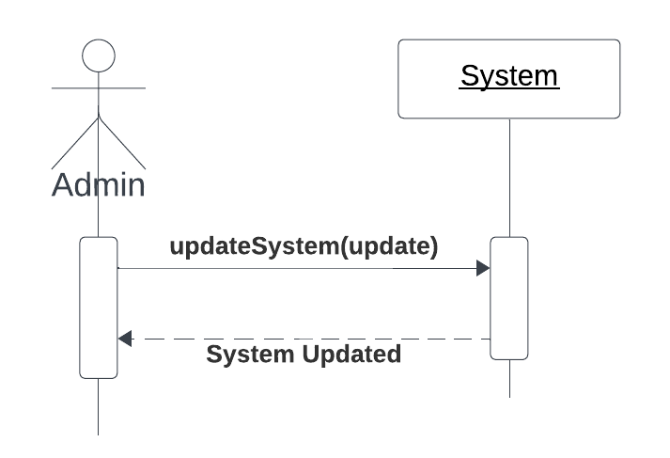

**10- Create Code**  
